Access For All: Integrated Educational and Employment System for Lupaoeños

Justine Joy S. Alo   
*Department of Information Technology*  
*Central Luzon State University*Science City of Muñoz, Philippines   
alo.justine@clsu2.edu.ph

Cenon Conrado C. Divina  
 *Vision and Image Processing Laboratory*  
*Department of Information Technology*  
*Central Luzon State University*Science City of Muñoz, Philippines   
cenonconrado.divina@clsu2.edu.phMary Graciel P. Lictawa  
*Department of Information Technology*  
*Central Luzon State University*Science City of Muñoz, Philippines   
lictawa.mary@clsu2.edu.ph

Ivan Christian L. Salinas  
Vision and Image Processing Laboratory  
*Department of Information Technology*  
*Central Luzon State University*Science City of Muñoz, Philippines   
ivanchristian.salinas@clsu2.edu.phEdwin B. Tejada  
*Department of Information Technology*  
*Central Luzon State University*Science City of Muñoz, Philippines   
tejada.edwin@clsu2.edu.ph

Angelika S. Balagot  
*Mobile and Cloud Computing Laboratory*  
*Department of Information Technology*  
*Central Luzon State University*Science City of Muñoz, Philippines   
balagot.angelikas@clsu2.edu.ph

*Abstract*—The “Access for All: Integrated Educational and Employment System for Lupaoeños” addresses inefficiencies in manual processes for scholarship and job applications. This web-based platform simplifies application procedures, expands opportunities, and fosters community development. Employing PHP, HTML, and CSS, the system enhances accessibility to scholarships and job opportunities, enabling applicants to connect seamlessly with educational and employment avenues. Real-time updates and analytics offer transparent and inclusive solutions for individual and communal growth.

***Keywords—scholarship, employment, web application, PHP, education***

# Introduction

A scholarship is a valuable form of financial assistance that helps students cover their education costs, such as textbooks and other related expenses. These scholarships support students in pursuing their educational ambitions and achieving their objectives. Typically, scholarships are awarded based on academic merit and financial need, ensuring students have access to the necessary resources to succeed.

Employment opportunities offer individuals diverse choices to secure jobs and work across various industries, including the public sector, government, and self-employment. These jobs provide viable career paths and opportunities for personal and professional growth. They are essential components of economic growth and individual development.

In the Municipality of Lupao, applying for scholarships and job vacancies is conducted through manual, in-person procedures. This method is challenging and time-consuming for residents as it requires physical visits to municipal offices, waiting in queues, and submitting physical documents. Additionally, incomplete and outdated information poses another obstacle, making it difficult for residents to find precise and timely details about scholarships and job opportunities within the local government unit (LGU). Consequently, this deficiency results in missed chances, as people may not know about opportunities aligned with their skills and career goals.

Scholarships and employment opportunities are critical for personal and community development. Scholarships enable financially constrained students in Lupao to pursue higher education, benefiting both individuals and the community. Similarly, work opportunities contribute to workforce readiness, lessen financial constraints on students, promote talent and merit, expand access to higher education through scholarships, and support economic growth and talent retention. These outcomes are transformative for both individuals and the community.

As proposed in "Access for All: Lupaoeños System," an efficient and effective job application procedure is crucial for Lupao residents. Simplifying the application process and making it more accessible allows people to locate appropriate information within the local government

# literature review

## Previous Studies and Findings

* **Smart Scholarship System** — The scholarship application process at Abu Dhabi University currently requires physical presence, causing inefficiencies. A proposed system streamlines applications, status tracking, and office assistance, enhancing educational access and promoting employment through apprenticeships [3].
* **Scholarship Management for International Students in China** —Li and Yang emphasized aligning scholarship systems with education strategies to ensure fairness and transparency. Similarly, the proposed Lupao system addresses inequitable distribution while fostering a supportive environment for students [4].
* **Online Tertiary-Level Scholarship Applications** —  
  Blancaflor et al. developed a web-based scholarship management system (APPly), emphasizing usability and efficiency. Enhancements include SMS notifications and centralized file management. The proposed system incorporates these features, improving access to job opportunities alongside scholarships [5].
* **Inclusion of Job Applications in E-Government Systems** — Estoquia et al. proposed a system offering analytics dashboards and real-time communication for job applicants and employers. The proposed Lupao system adopts similar features, ensuring seamless interaction and status updates [4].
* **Job Standard Parameters from Online Vacancies** — Putro and Rakhmawati demonstrated the efficiency of online job vacancy systems. The proposed system builds on this by providing detailed job listings and direct communication channels for applicants and employers [8].

## Existing Alternatives

* **SMS Notification for Scholarship Management** — This system uses SMS to manage applications but lacks comprehensive scholarship listings. The proposed system enhances this with data dashboards and messaging features for better usability [9].
* **Job Matcher with Collaborative Filtering** — Mendez and Bulanadi introduced a system for matching graduates’ skills with job vacancies. The proposed system extends this functionality by integrating job postings for private sectors and enabling real-time employer-applicant interactions [6].
* **Civil Service Commission (CSC) Job Portal** — The CSC portal lists government vacancies but faces security concerns. The proposed system incorporates ID-based authentication to prevent fraud and ensure data integrity [1].
* **E-Scholarship Application System** — Pascual’s E-Scholarship system simplifies scholarship applications but is limited to specific qualifications and fields. The proposed system offers equal access to all residents, without restrictions on courses or entrance exams [7].
* **Web-Based Information Systems for Scholarships** — Existing systems improve accessibility but lack data analysis features. The proposed system unifies scholarships and job opportunities with analytics-driven notifications and messaging capabilities [3].

## Gaps in Existing Research

1. 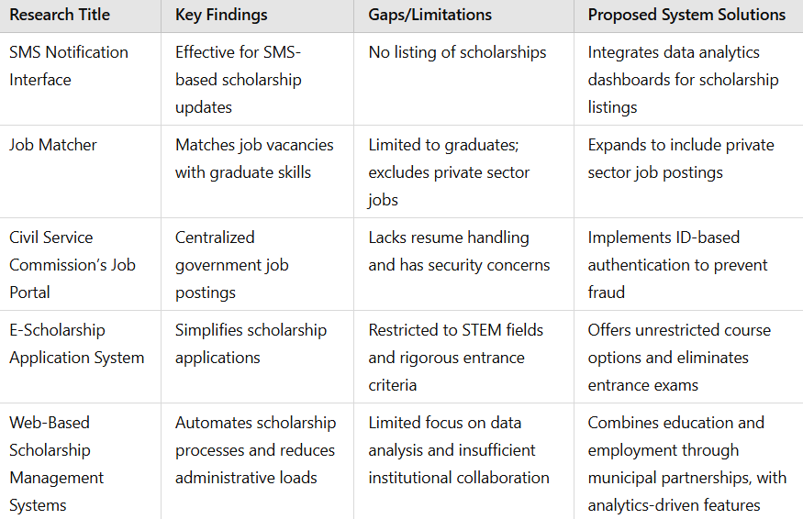Gaps In Existing Research
2. 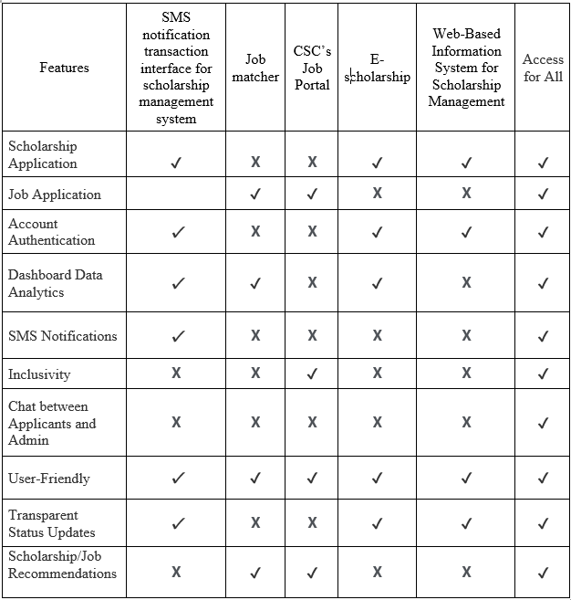Features Of Existing Alternatives Vs. The Prosposed System

## Synthesis

In the Philippines, managing scholarships and job placements is challenging due to high applicant volumes and limited opportunities. Existing systems, such as QR code tracking and SMS notifications, provide real-time updates, while job matcher web applications utilize collaborative filtering to align qualifications with job openings. The Civil Service Commission (CSC) lists government job vacancies but delegates application management to individual agencies. Similarly, the E-Scholarship Application System improves scholarship application accessibility through a web-based platform. Despite these advancements, limitations persist. The proposed system seeks to integrate scholarship and job application processes into a unified platform, enhancing efficiency, accessibility, and transparency for users.

# methodology

The Software Development Life Cycle (SDLC) methodology will be employed to develop the proposed system. The SDLC ensures that the system integrates education and employment processes in the Lupao LGU. This methodology consists of several phases: Planning, Analysis, Design, Implementation, Testing & Integration, and Maintenance. Below is the detailed approach for each phase

.

1. 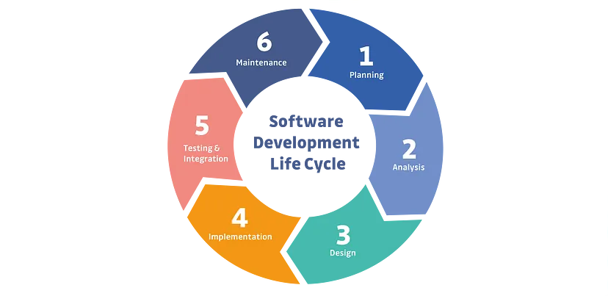Software Development Life Cycle (SDLC)

## Planning

In this phase, the main goals and issues will be identified and evaluated. The aim is to integrate education and employment systems for the Lupaoeños. A major objective is to automate the manual processes of data collection and storage, typically carried out by the Lupao LGU. To gather information, the developers will interact with key personnel from HR, IT, and other departments. The following questions will be addressed:

1. What is the current status of the LGU Lupao's scholarship programs and job placement services? How are these handled within the LGU?
2. How are students in Lupao informed of available scholarships and job openings?
3. What are the specific requirements for scholarships and job openings available through the LGU?
4. Does the LGU maintain records of the number of scholarships awarded, the success rate of applicants, and job placements?
5. How does the LGU manage information regarding scholarships and employment opportunities?
6. What are the problems with the current manual tracking of scholarships and job opportunities? Where can automation be beneficial?
7. Does the LGU have any future plans to implement a system that offers scholarships or job placements?

## Analysis

The analysis phase examines the system's components and interactions, identifying strengths and weaknesses to inform future improvements. A feasibility study evaluates the project's economic, technical, operational, and schedule feasibility, determining whether the benefits outweigh the limitations of the existing system.

* **Feasibility Study**—The feasibility study assesses the viability of the proposed system by identifying tasks, estimating durations, sequencing them logically, ensuring resource availability, and developing contingency plans. It evaluates technical, operational, and economic factors to determine if the project can be realistically completed within the specified time frame.
* **Technical Feasibility—**The current infrastructure of the Lupao LGU will be evaluated to ensure it can support the proposed system. The computer literacy level of users within the LGU will also be considered to ensure they can operate the system effectively.
* **Operational Feasibility—**The operational feasibility will assess whether the system aligns with the LGU’s current operations and goals.
* **Economic Feasibility—**Economic feasibility will be assessed by estimating available resources and the potential impact on the community's education and employment opportunities.

## Design

In this phase, the design for the "Access for All: Integrated Educational and Employment System for Lupaoeños" will be developed, including DFDs, UML diagrams, and prototypes. The focus will be on a user-friendly interface, efficient data organization, and system security.

* **Use Case Diagram—**This diagram will represent interactions between users (admins, applicants, owners) and the system. Users can create accounts, log in, view dashboards, and communicate through chat. Admins and owners can manage job and scholarship applications. A detailed use case diagram is provided in Appendix A.
* **Context Diagram—**This diagram will show the overall functionality of the system and how it interacts with users. The system will manage applicant and employer data and process applications. Announcements and SMS notifications will be sent to applicants.
* **Data Flow Diagram (DFD)—**This will visualize the flow of data from entry to processing. Applicants will submit applications, which will be processed and stored in databases. Admins and owners will manage and evaluate the data. SMS notifications will be sent upon completion.
* **Exploded DFD (Processes 1–4)—**Detailed breakdowns of processes like managing applicant accounts, managing scholarship/job applications, announcement management, and message management will be provided.
* **Entity Relationship Diagram (ERD)—**The ERD will show how applicants, owners, and admins interact in the application process, from submitting applications to receiving SMS notifications.
* **Relational Diagram—**This diagram will show the relationships between entities (applicants, jobs, scholarships, applications) and how they interact in the database.

## Implementation

The implementation phase employs PHP for the back end and HTML and CSS for the front end. The development team ensures thorough coding to minimize errors and promptly addresses any issues. The system undergoes rigorous testing to evaluate functionality, and user feedback is collected to address concerns and align the system with client and user expectations.

## Integration

To ensure functionality and meet user expectations, the proposed system will undergo a comprehensive testing and debugging phase prior to deployment. As outlined in Table 3, a standardized test case template will be used to identify and address potential issues. IT experts will rigorously evaluate the system’s strength and reliability during testing, ensuring its robustness and contributing to its continuous improvement.

1. 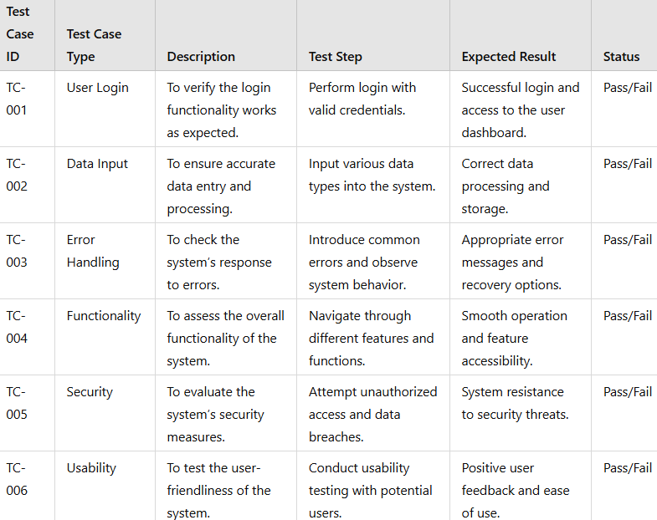Test Case

This test case table is sourced from ResearchGate, but the developers have customized the content to ensure efficient testing and system integration. The table helps thoroughly test the system from different perspectives, such as functionality, security, and user experience. It defines specific test cases for different aspects of the system to ensure that the software is robust, secure, and user-friendly.

## Maintenance

In the final phase, the development team will provide adjustments and ongoing support to ensure the system operates smoothly. A user manual will be supplied, and feedback from clients will guide improvements. Maintenance will adhere to the terms in the MOA or SLA, encompassing bug fixes, security updates, and performance enhancements. Additionally, the team will assist with installation, troubleshooting, and system migration as required.

# Result and discussion

This chapter provides a detailed overview of the results obtained from each methodology phase, specifically focusing on planning, analysis, design, implementation, testing, and maintenance. Each phase played a vital role in shaping the project, and the outcomes are instrumental in evaluating its effectiveness in meeting the established objectives and requirements.

Furthermore, the insights gained from this process offer a comprehensive reference for future researchers and developers who aspire to refine and improve the system, ensuring they can build upon the foundations laid in this project.

## Planning

A series of visits to the Human Resource Office in the Municipality of Lupao were conducted to collect data. Authorized personnel from departments such as Human Resources and Information Technology provided insights into existing processes. Key responses to the questions posed during these discussions are summarized below:

1. What is the current status of the LGU Lupao's scholarship programs and job placement services? How are these handled within the LGU?

**HR Officer*:*** *“Both scholarship programs and job placement services are done traditionally wherein applicants submit their applications physically and applications are reviewed manually.”*

1. How are students in Lupao informed of available scholarships and job openings?

**HR Officer:** *“For scholarship opportunities, it is posted to the Mayor's Facebook page while job openings are posted on a bulletin board in front of the HR office. However, this method may not always reach all residents efficiently, resulting in missed opportunities.”*

1. What are the specific requirements for scholarships and job openings available through the LGU?

**HR Officer:** *“For scholarship requirements, a photocopy of barangay indigency, school ID, certificate of enrollment, and latest grades are needed while for job openings, it depends on the job roles being advertised but commonly, a government-issued ID and barangay indigency is a must.”*

1. Does the LGU maintain records of the number of scholarships awarded, the success rate of applicants, and job placements?

**IT Officer:** *“We only have the total numbers of students that are accepted for disbursement of the scholarship in Excel and printed copy but other than that, we don’t have the success rate of the scholarship applicants nor the successful job placements”*

1. How does the LGU manage information regarding scholarships and employment opportunities?

**IT Officer:** *“Information is maintained manually, specifically, a soft copy was saved in an Excel file and printed copies are stored in a physical folder.”*

1. What are the problems with the current manual tracking of scholarships and job opportunities? Where can automation be beneficial?

**HR Officer:** *“The manual method is time-consuming, prone to errors, and inefficient for both the applicants since they have to physically submit their applications and to us because everything is done manually.”*

1. Does the LGU have any future plans to implement a system that offers scholarships or job placements?

**HR Officer:** *“To be honest, none but because of the opportunity to have a system that the developers are proposing to implement, I can see that it will be helpful to our municipality.”*

## Analysis

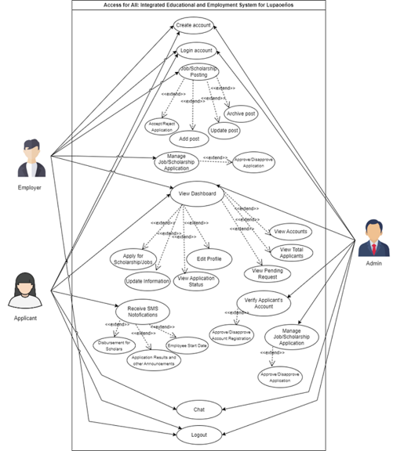**Feasibility Study** **—** The developers conducted a feasibility study to evaluate the project's technical, operational, and economic feasibility:

1. 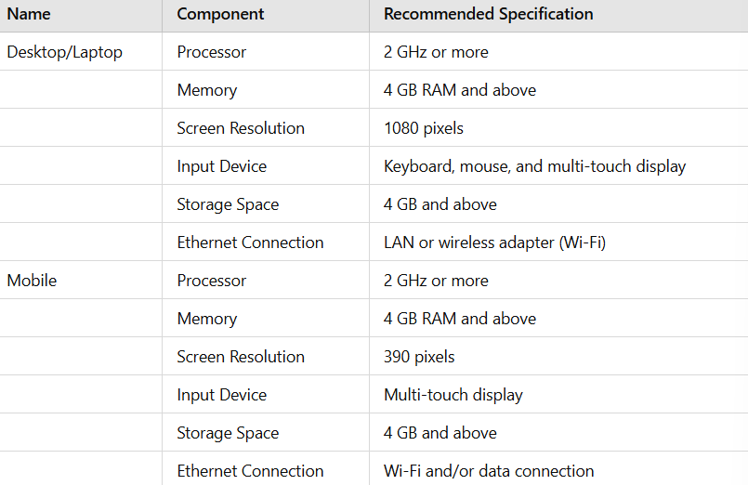Recommended System Requirements for desktop and mobile devices
2. 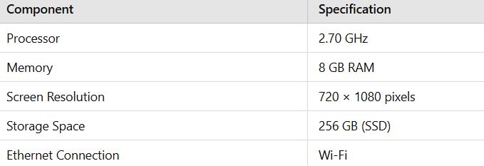lgu it offices desktop specification

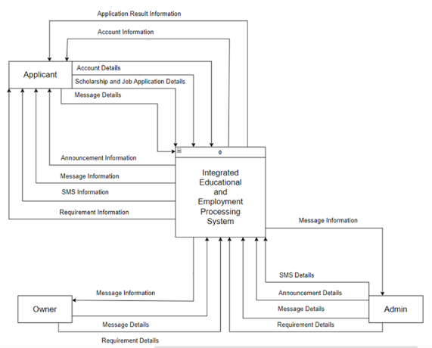 Technical Feasibility—As shown in Tables IV and V, the developers required essential tools, including a laptop or personal computer and a stable internet connection, to support communication during system development. Development tools such as Visual Studio Code were used for coding and editing, while Chrome facilitated user interface previews. Initially, phpMyAdmin was employed for database management before full implementation.

1. 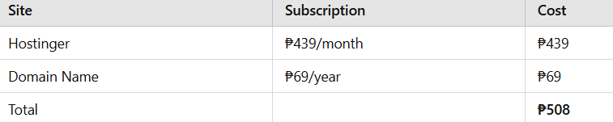Subscription cost of the proposed system

As shown in Table VII, the system Economic Feasibility, and was deployed on Hostinger for a monthly fee of ₱439, and PHPMailer was integrated with Gmail for email communication. After finalizing the system, access was given to the client, and a demonstration was conducted for the LGU IT officer. Job seekers, students, and employers tested the system, while developers assisted with account registration and document submission, gathering sample data for testing.

## Design

During the design phase, the developers created data flow diagrams (DFD) and Unified Modeling Language (UML) diagrams, including use case and context diagrams, to meet the documented requirements. Prototyping was used to design the system interface, define applicant data input methods, and organize data for easy access by administrators. Security restrictions and constraints were also implemented to protect the system and its users.

1. Use Case Diagram

The use case diagram illustrates the interactions among Employers, Applicants, and Admins within the system. Employers manage job postings and applicants, Applicants submit applications and track their status, while Admins verify users and oversee application processes. Shared functionalities, including chat and logout options, are emphasized, alongside dependencies among system functions, ensuring a cohesive and user-centric design.

1. Context Diagram

Figure 3 shows the Data Flow Diagram (DFD) for the "Integrated Educational and Employment Processing System," highlighting interactions among the Applicant, Owner, Admin, and the system. The Applicant shares account details and application information, the Owner provides messages and requirements, and the Admin manages messages, SMS, and announcements. The system centralizes these data flows for efficient management.

1. 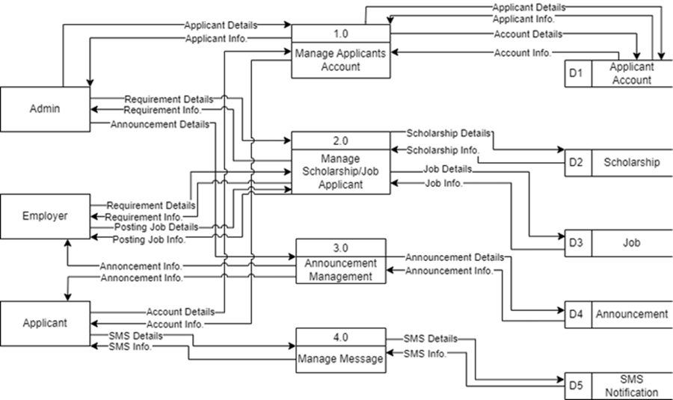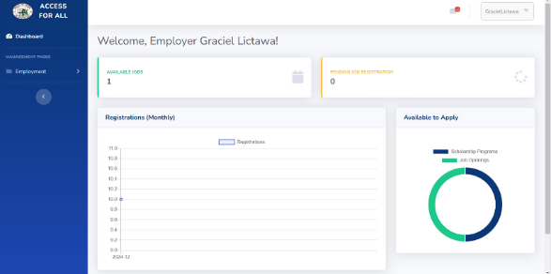Data Flow Diagram

Fig. 4 illustrates the Data Flow Diagram (DFD) of the proposed system, showing the interaction between entities, processes, and data stores. It centralizes and automates the management of scholarships and job opportunities in Lupao. The DFD highlights data flow among Admins, Employers, and Applicants, including account details, scholarship and job information, announcements, and SMS notifications, improving efficiency, accessibility, and transparency.

## Implementation

The developers utilized PHP for the back end and HTML and CSS for the front end. The development team ensured that the code was error-free and addressed any issues that arose during development. As the system took shape and the code was assembled, it was thoroughly tested to evaluate its overall functionality and performance. The team also collaborated closely with users to gather feedback and address concerns, ensuring that the system successfully met the needs and expectations of both clients and users.



1. User Interface for Login

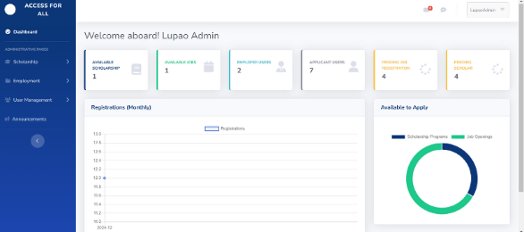 The login interface ensures secure authentication with fields for email, password, and options for registration or password recovery. Its engaging design enhances user experience.

1. ser Interface of Admin Dashboard

The admin dashboard provides administrators with an overview of key metrics and data visualizations, supporting efficient management and navigation.

1. User Interface for Employer Dashboard

The employer dashboard offers a clear view of announcements and activities, enabling employers to access essential information and actions easily.

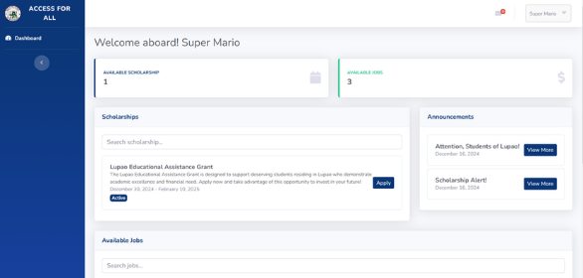

1. User Interface for Applicant

The applicant dashboard simplifies access to scholarships and announcements, ensuring a smooth and user-friendly application process.

## Integration

During the testing phase, IT experts were invited to thoroughly examine the system to ensure its functionality and performance. Additionally, end-users were given the opportunity to interact with the system. This collaborative approach ensured the system's reliability and alignment with the needs of the Municipality of Lupao. Detailed test cases from IT experts, employers, and users are outlined below.

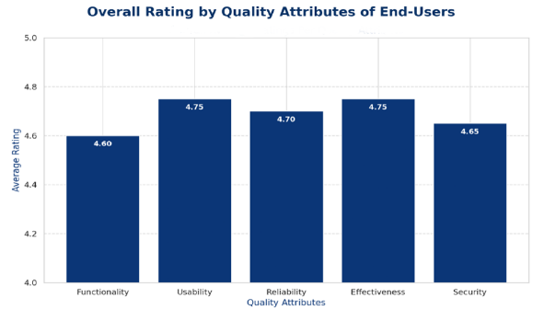

1. 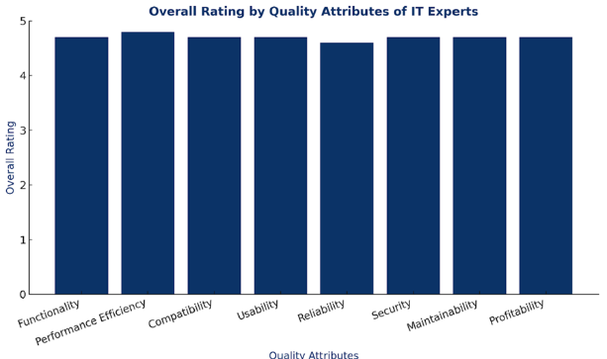Results of Evaluation of End-User
2. Results of Evaluation of Employers
3. 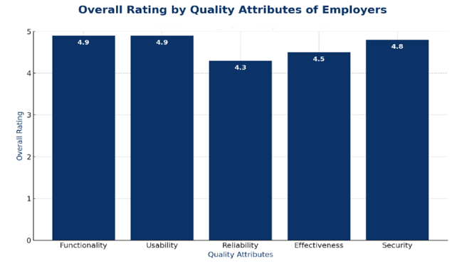Results of IT Experts’ Evaluation

Figures 9, 10, and 11 provide a comparative analysis of quality attribute evaluations by end-users, IT experts, and employers. End-users (Fig. 9) prioritize usability and effectiveness, each with ratings of 4.75, while functionality receives the lowest rating at 4.60. IT experts (Fig. 11) show consistently high ratings across all attributes, indicating a balanced evaluation. Employers (Fig. 10) rate functionality and usability highest at 4.9, but reliability is lower at 4.3, suggesting concerns about system dependability. These results highlight varying priorities among stakeholders, underscoring the need to address diverse quality expectations in software development.

## Maintenance

A comprehensive user manual is provided to assist clients in system operation. Maintenance, support, and upgrades are delivered in accordance with the terms outlined in the Memorandum of Agreement (MOA) or Service Level Agreement (SLA). These services include bug fixes, troubleshooting, upgrades, and security and performance updates. Technical support is offered for installation, configuration, and troubleshooting. Additionally, assistance with migration and end-of-life processes may also be included within the scope of the MOA.

# Conclusion

The development and implementation of the Access for All: Integrated Educational and Employment System effectively addresses the challenges faced by residents in securing scholarships and job opportunities. This initiative aims to streamline the traditionally manual processes of applying for educational and employment opportunities by offering a centralized and user-friendly platform.

The system's primary contributions lie in its user-centered design, which has been carefully developed to enhance the efficiency and transparency of the application process. A significant feature of the system is the integration of SMS notifications and additional email notifications, which ensure that users receive timely updates regarding their scholarship and job applications. This functionality keeps students and job seekers informed about their application status and any necessary next steps, significantly reducing anxiety and uncertainty.

Furthermore, the system incorporates robust data analytics dashboards that provide valuable insights into application trends and success rates. These dashboards empower users to track the progress of their applications in real-time, enabling them to make informed decisions regarding their educational and career trajectories.

For local government officials and private sector employers, the system offers considerable advantages by streamlining the recruitment process. The integration of efficient application management features simplifies the review of scholarship and job applications, allowing for the identification of qualified candidates with greater ease. Consequently, both job seekers and employers benefit from a more efficient and transparent recruitment experience, thus strengthening the connection between education and employment opportunities within the community.

##### References

1. (n.d.). "Civil Service Commission - The Official Website of the Philippines Civil Service Commission," accessed May 21, 2024. [Online]. Available: <https://csc.gov.ph/>
2. (n.d.). "Civil Service Commission - The Official Website of the Philippines Civil Service Commission," accessed May 21, 2024. [Online]. Available: <https://csc.gov.ph/>
3. M. S. Al-Ayyubi and B. Maulana, "Designing a Web-Based Information System for Scholarship Management: Supporting Access and Rapid Dissemination of Information," *ITEJ*, vol. 8, no. 1, June 28, 2023. [Online]. Available: <https://doi.org/10.24235/itej.v8i1.111>
4. D. F. Berido, S. A. A. Pingol, P. D. Ramil, K. D. Villacaol, C. J. Centeno, and D. S. Abando, "Development of scholarship automation system for student qualification program applied to college universities using regression analysis," *World Journal of Advanced Research and Reviews*, Nov. 30, 2023. [Online]. Available: https://doi.org/10.30574/wjarr.2023.20.3.2421
5. E. Blancaflor, P. A. I. Caseñas, L. J. H. Rocamora, J. I. Y. Rosete, and W. Rey, "APPly: A Design of an Online Tertiary Level Scholarship Application Management System," in *Proc. Int. Commun. Eng. Cloud Comput. Conf. (CECCC)*, Oct. 28-30, 2022, pp. 74-78. [Online]. Available: <https://doi.org/10.1109/CECCC56460.2022.10069218>
6. J. S. Mendez and J. D. Bulanadi, "Job Matcher: A Web Application Job Placement Using Collaborative Filtering Recommender System," *Consortia Academia*, vol. 9, no. 2, pp. 103-120, July 13, 2020. [Online]. Available: <https://doi.org/10.5861/ijrse.2020.5810>
7. M. R. Pascual, "E-Scholarships Application System - Undergraduate," Feb. 25, 2023. [Online]. Available: <https://www.scribd.com/>
8. H. H. Paturo and N. Rakhmawati, "Job Standard Parameters from Online Job Vacancy," *IPTEK Journal of Proceedings Series*, Mar. 9, 2021.
9. K. A. S. Secugal, J. P. Sermeno, and N. E. Mistio, "QR-Code tracking and SMS notification transaction interface for scholarship management system," *Int. J. Appl. Sci. Eng.*, vol. 18, June 21, 2021. [Online]. Available: <https://doi.org/10.6703/IJASE.202106_18(4).004>
10. T. Aytemiz, "How does the SDLC play a role in the success of product development and launch?" *Medium*, Jan. 14, 2023. [Online]. Available: <https://medium.com/agileinsider/how-does-the-sdlc-play-a-role-in-the-success-of-product-development-and-launch-a17baaac1054>